

Practices for Secure Software Report

Table of Contents
Document Revision History 3
Client 3
Instructions 3
Developer 4
1. Algorithm Cipher 4
2. Certificate Generation 4
3. Deploy Cipher 4
4. Secure Communications 4
5. Secondary Testing 4
6. Functional Testing 4
7. Summary 4
8. Industry Standard Best Practices 4

Document Revision History

Version | Date | Author | Comments
1.0 | 04.18.2026 | Arrianna Arline

Client



Instructions

Submit this completed practices for secure software report. Replace the bracketed text with the relevant information. You must document your process for writing secure communications and refactoring code that complies with software security testing protocols.

- Respond to the steps outlined below and include your findings.
- Respond using your own words. You may also choose to include images or supporting materials. If you include them, make certain to insert them in all the relevant locations in the document.
- Refer to the Project Two Guidelines and Rubric for more detailed instructions about each section of the template.

Developer
Arrianna Arline

Algorithm Cipher

The recommended encryption algorithm cipher for this application is Advanced Encryption Standard (AES) with a 256-bit key (AES-256), combined with SHA-256 hashing for data integrity and RSA for secure key exchange. AES is a symmetric encryption algorithm that securely encrypts and decrypts data using the same secret key. It is widely used in modern systems because it is efficient, fast, and resistant to brute-force attacks when used with a 256-bit key size.

SHA-256 is used as the cryptographic hash function to verify data integrity. It produces a fixed 256-bit output regardless of input size, meaning even the smallest change in the original data results in a completely different hash value. This makes it useful for checksum verification and detecting tampering in transmitted data.

AES is a symmetric encryption method, meaning the same key is used for both encryption and decryption. In contrast, RSA is an asymmetric encryption algorithm that uses a public and private key pair. RSA is typically used to securely exchange AES keys rather than encrypting large amounts of data directly. This combination allows the system to benefit from both speed (AES) and secure key distribution (RSA).

Random numbers are also important in encryption because they are used to generate secure encryption keys, initialization vectors (IVs), and salts. Without randomness, encrypted data could become predictable and vulnerable to attack. Secure random number generation ensures that each encryption instance is unique and difficult to reverse-engineer.

Historically, older encryption standards such as DES (Data Encryption Standard) used smaller key sizes (56-bit), which are no longer secure due to advances in computing power. AES replaced DES as the modern standard in 2001 and remains widely used today. Current encryption practices favor AES-256 for symmetric encryption, RSA or elliptic curve cryptography (ECC) for asymmetric encryption, and SHA-2 family algorithms such as SHA-256 for hashing and data integrity.

Overall, AES-256, SHA-256, and RSA together provide a strong, modern, and industry-standard approach to securing sensitive financial data in web applications like Artemis Financial’s system.

Certificate Generation

Self-signed certificates were generated using the Java Keytool utility within Eclipse. A keystore file (.jks) was created to store the certificate and private key. The certificate was then exported as a .cer file to verify that it was successfully generated.

The keystore was configured in the application.properties file, including the key alias, password, keystore location, and type. This allowed the application to support SSL and establish secure HTTPS communication.

A screenshot of the exported CER file is included to demonstrate successful certificate creation.
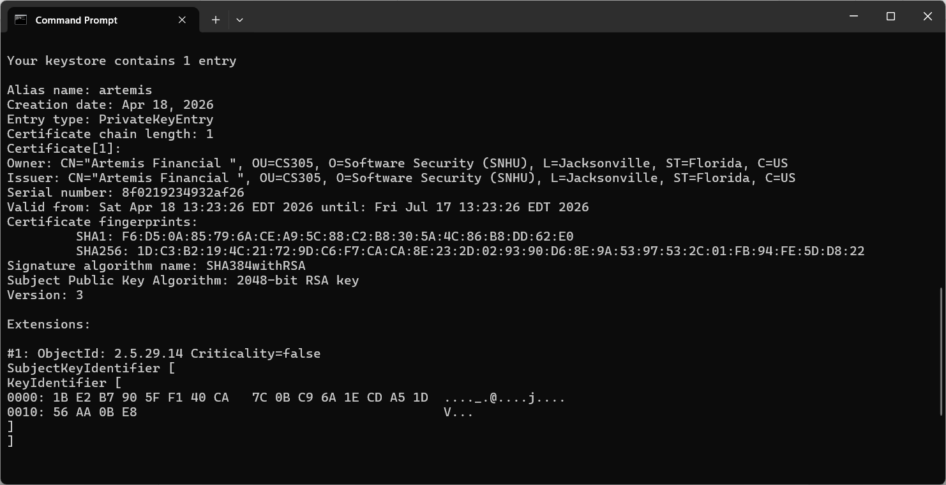

Deploy Cipher

The cryptographic hash algorithm SHA-256 was implemented by refactoring the application code. A HashService class was created to generate a SHA-256 hash from a given data string. This was integrated into the application through a REST endpoint that returns both the original data and its corresponding hash value.

The checksum verification demonstrates that the same input always produces the same hash output, ensuring data integrity. Any change in the data results in a completely different hash, making it effective for detecting tampering.

A screenshot of the running application displaying the unique data string, my name, and the generated hash is included as proof of successful implementation.


Secure Communications

Secure communication was implemented by configuring the application to use HTTPS instead of HTTP. This was achieved by updating the application.properties file to include SSL settings such as the server port (8443), keystore location, password, alias, and type.

After compiling and running the application, the secure connection was verified by accessing the endpoint using:

https://localhost:8443/hash

The browser confirmed the connection was secure, demonstrating that SSL encryption was successfully applied.

A screenshot of the browser showing the secure HTTPS connection is included.

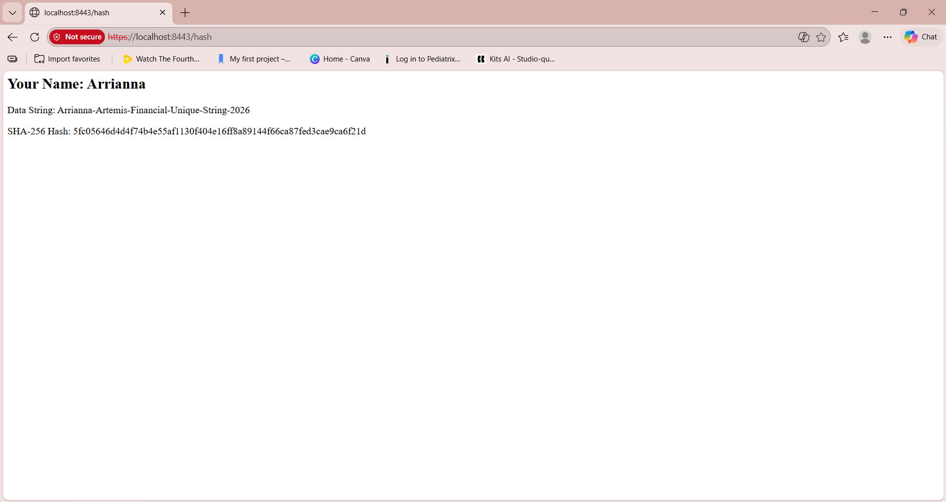

Secondary Testing

A secondary static analysis was performed using the OWASP Dependency Check Maven plugin to identify any known vulnerabilities in project dependencies. The scan was successfully executed after configuring an API key for access to the National Vulnerability Database (NVD).

The results showed that no critical vulnerabilities were introduced during the refactoring process. This confirms that the added security features did not negatively impact the overall security of the application.

A screenshot of the successful build execution and the generated dependency-check report is included.

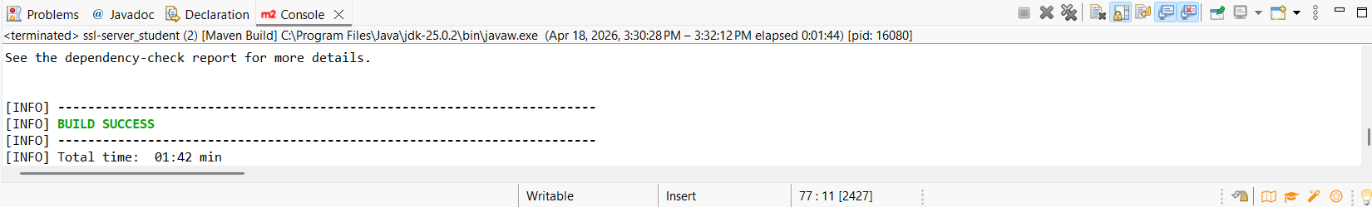
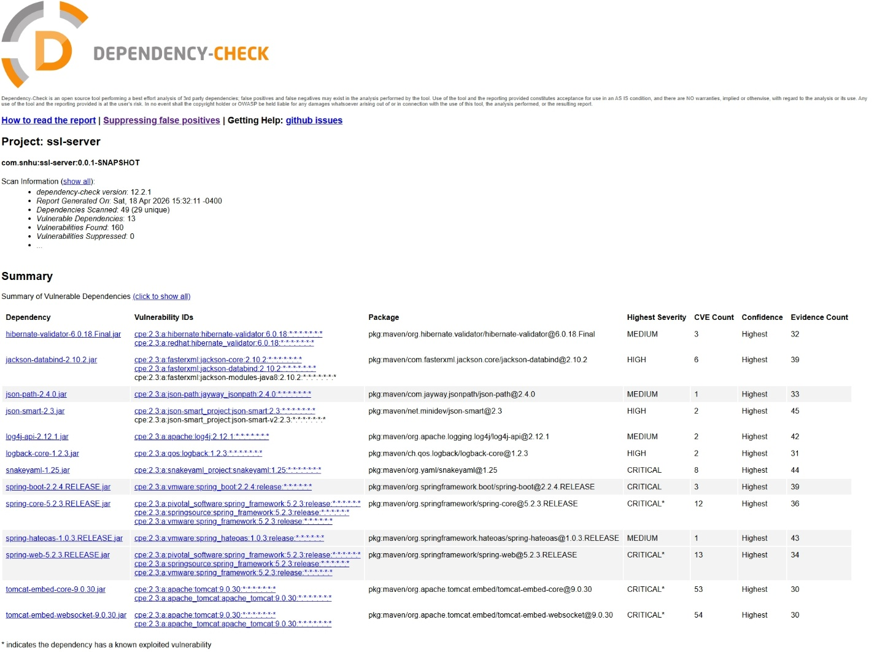

Functional Testing
The application was manually reviewed to identify syntactical, logical, and security vulnerabilities. No syntactical errors were found, as the application compiled and executed successfully without issues. Logical testing confirmed that the system correctly processes input data and generates a SHA-256 hash consistently. From a security perspective, improvements were implemented by replacing HTTP with HTTPS, ensuring encrypted communication, and by introducing hashing for data integrity verification. Additionally, sensitive information such as API keys was not hardcoded and instead managed through environment variables. These measures confirm that the application functions correctly and adheres to secure coding practices.


Handling Errors or Vulnerabilities

If errors or new vulnerabilities were identified during testing, the development process would follow an iterative approach. The identified issues would first be analyzed to determine their root cause, whether syntactical, logical, or security related. Appropriate fixes would then be applied, such as correcting code errors, improving logic, or strengthening security configurations. After implementing these changes, the application would be retested using both functional and static analysis tools, including the OWASP dependency-check tool. This process would continue until no new vulnerabilities or errors were detected. This iterative approach ensures continuous improvement and alignment with secure software development practices.

Summary

The code was refactored to improve security by addressing multiple areas identified in the vulnerability assessment process. Based on the process flow, I focused on identifying risks, implementing security controls, and verifying those controls through testing. Specifically, I addressed insecure communication by converting HTTP to HTTPS using an SSL certificate, which ensures encrypted data transmission. I also added a checksum verification feature using the SHA-256 hashing algorithm to maintain data integrity during transfers.

My process for adding layers of security started with identifying weaknesses in the original application, such as lack of encryption and no data verification. I then implemented encryption through HTTPS, added hashing for integrity, and secured sensitive information by using environment variables instead of hardcoding values. After implementing these changes, I tested the application by running it, verifying the secure connection, and performing a dependency-check scan to ensure no additional vulnerabilities were introduced. This layered approach strengthens the application by protecting data at multiple levels rather than relying on a single security measure.

Industry Standard Best Practices

Industry standard best practices were applied throughout the refactoring process to reduce security risks and maintain the integrity of the application. One key practice was enforcing secure communication through HTTPS, which aligns with modern security standards for protecting data in transit. Another best practice was using a strong cryptographic hash function (SHA-256) to ensure data integrity. Additionally, sensitive information such as API keys was not hardcoded into the application, but instead stored securely using environment variables, which prevents exposure in the codebase.

To maintain the existing security, I ensured that new features did not interfere with the current functionality or introduce new vulnerabilities. The use of static analysis through the dependency-check tool helped confirm that all dependencies remained secure after modifications.

Applying these best practices is important to the company’s overall well-being because it protects sensitive financial data, reduces the risk of cyberattacks, and helps maintain customer trust. Security coding also helps the company stay compliant with industry regulations and avoid potential financial or reputational damage. Overall, following these standards ensures the software is reliable, secure, and prepared for real-world use.

